SPRING-FORD RAMS

HS Band Program – www.springfordbands.org
350 S. Lewis Road, Royersford, Pennsylvania 19468 • 610-705-6001

WEST CHESTER CHRISTMAS PARADE PERFORMANCE/COMPETITION
THURSDAY, DECEMBER 5, 2019
Full Ensemble Rehearsal, 5:30 to 8:00 PM
5:30 PM – Meet in 10-12 Band Hall
7:30 PM to 8:00 PM – Instrument Decorating, BRING BATTERIES AND LIGHTS
FRIDAY, DECEMBER 6, 2019
DOWNTOWN WEST CHESTER, PA
ITEMS YOU WILL NEED: BLACK SHOES, BLACK SOCKS, UNIFORM, INSTRUMENT, WATER
4:15 PM Meet at 10-12 Band Hall, Grab Uniforms, Load Instruments
4:45 PM Departure to West Chester
6:00 PM Arrive at Bus Staging Area: Hillsdale Elementary School
Unload, Warm Up
6:45 PM Move to Assembly Area @ West Market Street and Brandywine Street
7:15 PM Parade Kicks Off
8:15 PM Drum Majors head to New and Market Street for Awards Ceremony
Rest of Band returns to Buses, Loads Equipment, Changes
9:15 PM Departure for SFHS
10:00 PM Return to Spring-Ford, Unload
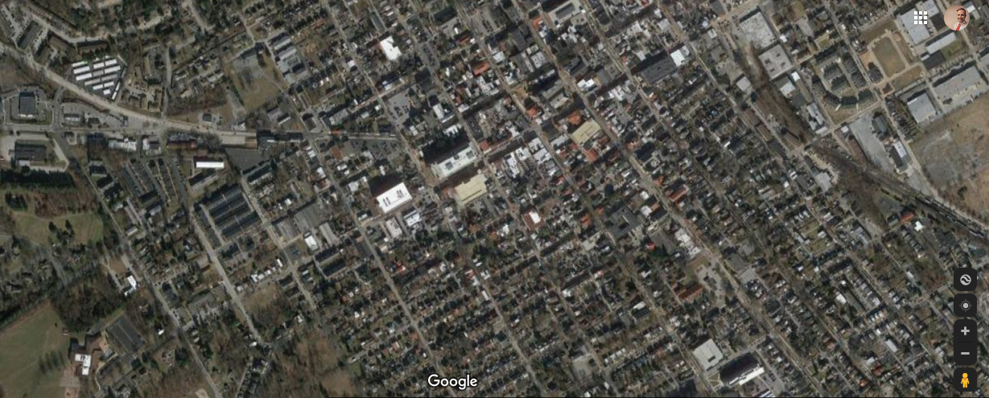
Buses @ Hillsdale Elem.
Assembly Staging @ W. Market and Brandywine
Parade Area:
See Below

